**EAST WEST UINVERSITY**

**Department of Computer Science and Engineering**

**Post Lab**

**Semester:** Summer’17

**Course code:** CSE 251 (2)

**Course title:** Electronic Circuits

**Experiment No:** 04

**Experiment title:** Adder and Amplifier Circuits using 741 Op Amp

**Submitted to:**

Surajit Das Barman

Senior Lecturer

Department of CSE

East West University

**Submitted by:**

Kowser Mahmud Tanim

ID: 2015-2-60-062

Group No: 05

Group IDs: 2015-2-60-078, 2015-2-60-057, 2015-2-60-108

**Date of performance:** 04/07/2017

**Date of report submission:** 09/08/2017

**Experiment No:** 04

**Experiment title:** Adder and Amplifier Circuits using 741 Op Amp

**Objectives:**

1. To familiarize with the 741 Op Amp Integrated Circuit (IC).
2. To design and construct an adder using 741 Op Amp.
3. To design and construct an amplifier using 741 Op Amp.

**Circuit Diagram:**

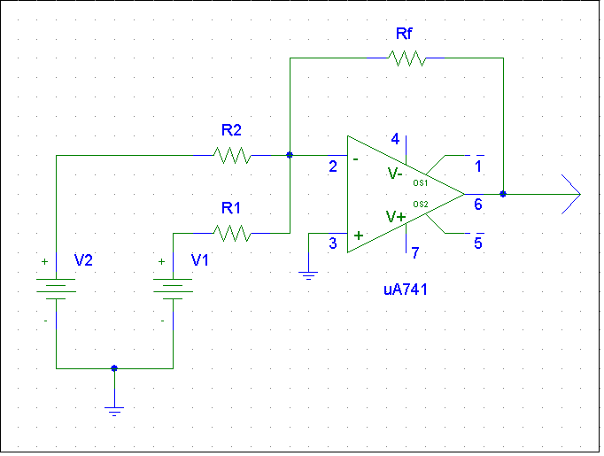

Figure 1: An adder circuit using 741 Op Amp

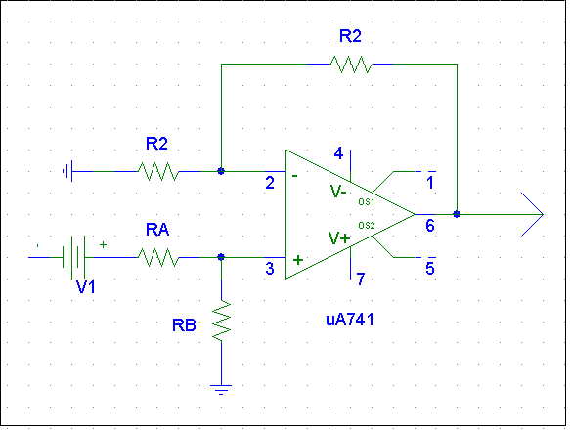

Figure 2: A non-inverting amplifier circuit using 741 Op Amp

**Answers to the Post-Lab Report Questions:**

**(1)**

Here,

V1=5V; V2=2V;

Output voltage,

Vo= -(V1+2 V2)= -(5+4)= -9V

And from the measurement, Output voltage,

Vo = -9.3V

Measured and pre-lab Output Voltage is close to each other. So the design is verified.

**(2)**

Amplitude measured in step 4 is = 5.04

And in our pre-lab design circuit amplitude is = 4.56

Comment:

Measured and pre-lab amplitude are close to each other. So this design is verified.

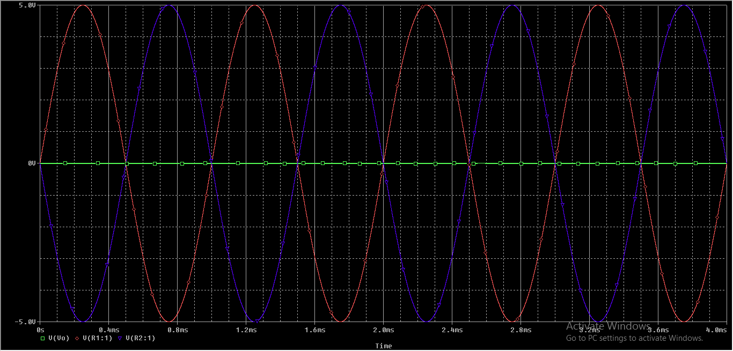

**(4)**

In Phasor domain,

V1 = 2.5˪ $0^{0}$ V, V2 = 2.5˪ ${90}^{0}$ V

V1 + V2 = 2.5˪ $0^{0}$ + 2.5˪ ${90}^{0}$ = 3.536˪ ${45}^{0}$ V

In time domain,

V1 = 2.5 $\sin{(2000πt+0^{0})}V$

V2 = 2.5 $\sin{(2000πt+{90}^{0})}V$

V1 + V2 =2.5($\sin{(2000πt+0^{0})}+\sin{(2000πt+{90}^{0}))}V$

Comparison between Pspice Calculation and Calculator Calculation:

|  |  |  |
| --- | --- | --- |
|  | From Pspice | From calculation |
| Amplitude | 3.536 | 05 |
| Phase angle | $${45}^{0}$$ | $${45}^{0}$$ |
| Time period | 2ms | 2ms |

**(5)**

AMPLIFIER CIRCUIT:

Comparison between measured voltages at nodes A, B, C, and D with pre-lab result:

|  |  |  |
| --- | --- | --- |
|  | Pre-lab result voltage (V) | Measured voltage (V) |
| A | 1 | 1.08 |
| B | 0.85 | 0.9001 |
| C | 0.85 | 0.9162 |
| D | 5.54 | 5.524 |

Comment:

There are some difference between Calculated value and Pre-lab value because in lab temperature and some problem effect on the measured value.

**(6)**

Measured voltage of,

B = 0.9001V

C = 0.9162V

Comment:

We see that both B and C are about same. So the virtual ground of Op Amp is satisfied.

**(7)**

Here voltage in node

A = 1.08V

D = 5.524V

Gain = 5.524/1.08 = 5.11

From pre-lab our gain was = 5.54

**(8)**

Current through

R1 is I1 = .8064/ .8059= 1 mA

R2 is I2 = (.8076 – .9297) / 10 = -0.124 mA

RA is IA = (4.541– .9792) / 2.2 = 1.61 mA

RB is IB = 4.541 / 10 = 0.454 mA

Comparison between measured Values and calculated Values:

|  |  |  |
| --- | --- | --- |
| Currents | Measured Values(mA) | Calculated Values(mA) |
| I1 | 1 | 0.85 |
| I2 | -0.124 | -0.84 |
| IA | 1.61 | 1.15 |
| IB | 0.454 | .1517 |

Comment:

There are some difference between Calculated values and Measured Values because in lab temperature and some problem effect on the measured value.

**(9)**

Current I1= .8064/ .8059= 1 mA

Input Impedance: Z1= V1/I1= .9297/1= 0.9297 KΩ

Comparison between measured Values and calculated Values:

|  |  |  |
| --- | --- | --- |
| Impedance | Measured Values(mA) | Calculated Values(mA) |
| Z1 | 0.9297 KΩ | .8695 KΩ |

Comment:

Both values are different. There is some error in measurement.

Conclusion:

There are some difference in measured value and calculated value for temperature, equipment’s error or ignored value after decimal.